TDG was founded in Dec 2022, and established in June 2024 - vide Certificate No. SOCF-PPT6AAP, by the Registrar of Societies of the Attorney General’s Office in Kenya.
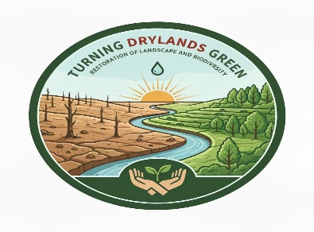
Restoration of Denuded Landscapes
Many reports classify this Country as 84%, or more, as Arid & Semi-Arid Lands (ASALs). No meaningful activities, let alone agriculture, can take place other than pastoralism that has, fairly, been successful; it supplies the bulk of meat consumed locally; live animals, and or their products exported to help earn this Country the much needed foreign exchange, as well as offer direct and indirect employment for bulk of its populace. We cannot take this for granted. Many times, neighboring communities have more often than not, experienced ethnic clashes for scarce resources (water, pastures etc.) and apparently, this area seems to be expanding, as abetted by Climate Change.
This expansive area often receives unreliable rainfall, with sporadic flushes that lead to landslides, destruction of human, as well as livestock life. Consequently, the bulk of residents have been forced to migrate, due to the prevailing harsh environment, with those remaining relying on Government’s relief supplies; rescue interventions are common. Occasionally, livestock off-take is undertaken to try salvage their only livelihood but without much success – over time; the area’s residents have been rendered poor, helpless, and the Donors (who have generously supported the interventions) that have been undertaken over time, have even questioned “when real development would begin…” This scenario cannot, and should not, be allowed to continue; something different should be tried (as the photos below depict an undesirable scene).
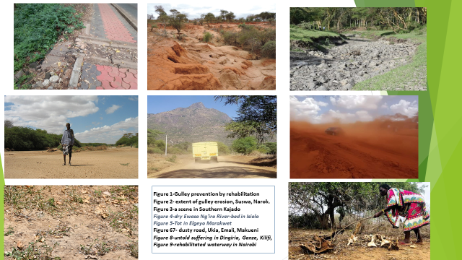
Turning Drylands Green was, therefore, established to “contribute to this development” through, “Rehabilitation of the vast & expanding Dryland Catchments towards the Restoration of their Denude Landscapes”; this should not, in any way, mean taking over or replicating anyone’s’ role..
This area supports a significant population and contributes to National Development, to the affected Communities' Food Security, Livelihoods, as well as the UN's Sustainable Development Goals.
It is unfortunate, this area is prone to disasters, and repetitively; has only been receiving respective but reactive responses in form of very costly Interventions
Turning Drylands Green comprise of individuals who worked in various and related projects in GoK, World Vision, World Bank etc. It is cognizant of the necessity to mobilize and empower the affected communities for genuine sustainability; and amongst our activities, we have prudent intentions to mobilize and empower them. With this in mind, are ready to engage in something different, in order to, at least, achieve tangible outcomes; thus we are conscious of what do, and how; what we need is support because the recovery activities therein are cash-intensive.

